**AIM:** Demonstrate use of listeners with advanced views like date pickers, spinners and lists.

**Statement:**

* Design a layout as shown below.
* The age must be calculated automatically and displayed on selecting date of birth.

**OUTPUT:**

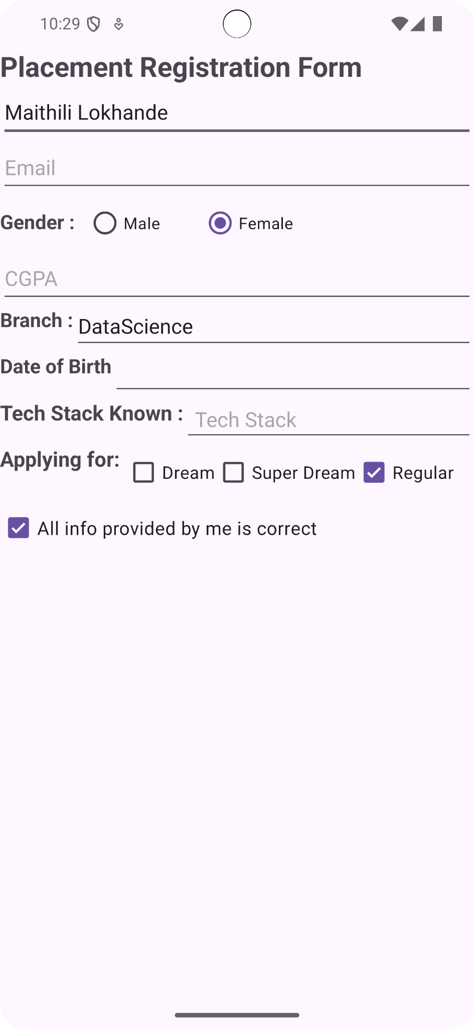

**JAVA CODE:**

import android.os.Bundle;

import androidx.activity.EdgeToEdge;

import androidx.appcompat.app.AppCompatActivity;

import androidx.core.graphics.Insets;

import androidx.core.view.ViewCompat;

import androidx.core.view.WindowInsetsCompat;

public class MainActivity extends AppCompatActivity {

@Override

protected void onCreate(Bundle savedInstanceState) {

super.onCreate(savedInstanceState);

EdgeToEdge.enable(this);

setContentView(R.layout.activity_main);

ViewCompat.setOnApplyWindowInsetsListener(findViewById(R.id.main), (v, insets) -> {

Insets systemBars = insets.getInsets(WindowInsetsCompat.Type.systemBars());

v.setPadding(systemBars.left, systemBars.top, systemBars.right, systemBars.bottom);

return insets;

});

}

}

**XML CODE**

:<?xml version="1.0" encoding="utf-8"?>

<androidx.constraintlayout.widget.ConstraintLayout xmlns:android="http://schemas.android.com/apk/res/android"

xmlns:app="http://schemas.android.com/apk/res-auto"

xmlns:tools="http://schemas.android.com/tools"

android:id="@+id/main"

android:layout_width="match_parent"

android:layout_height="match_parent">

<TextView

android:id="@+id/titleTextView"

android:layout_width="0dp"

android:layout_height="wrap_content"

android:text="Placement Registration Form"

android:textSize="24sp"

android:textStyle="bold"

app:layout_constraintEnd_toEndOf="parent"

app:layout_constraintStart_toStartOf="parent"

app:layout_constraintTop_toTopOf="parent" />

<EditText

android:id="@+id/nameEditText"

android:layout_width="0dp"

android:layout_height="wrap_content"

android:hint="Name"

android:minHeight="48dp"

android:inputType="textPersonName"

android:contentDescription="Enter your name"

app:layout_constraintEnd_toEndOf="parent"

app:layout_constraintStart_toStartOf="parent"

app:layout_constraintTop_toBottomOf="@id/titleTextView" />

<EditText

android:id="@+id/emailEditText"

android:layout_width="0dp"

android:layout_height="wrap_content"

android:hint="Email"

android:minHeight="48dp"

android:inputType="textEmailAddress"

android:contentDescription="Enter your email address"

app:layout_constraintEnd_toEndOf="parent"

app:layout_constraintStart_toStartOf="parent"

app:layout_constraintTop_toBottomOf="@id/nameEditText" />

<RadioGroup

android:id="@+id/genderRadioGroup"

android:layout_width="0dp"

android:layout_height="wrap_content"

android:orientation="horizontal"

android:minHeight="48dp"

app:layout_constraintEnd_toEndOf="parent"

app:layout_constraintStart_toStartOf="parent"

app:layout_constraintTop_toBottomOf="@id/emailEditText">

<TextView

android:layout_width="75dp"

android:layout_height="wrap_content"

android:text="Gender :"

android:textSize="17sp"

android:textStyle="bold" />

<RadioButton

android:layout_width="100dp"

android:layout_height="wrap_content"

android:text="Male"

android:minHeight="48dp" />

<RadioButton

android:layout_width="100dp"

android:layout_height="wrap_content"

android:text="Female"

android:minHeight="48dp" />

</RadioGroup>

<EditText

android:id="@+id/cgpaEditText"

android:layout_width="0dp"

android:layout_height="wrap_content"

android:hint="CGPA"

android:inputType="numberDecimal"

android:minHeight="48dp"

android:contentDescription="Enter your CGPA"

app:layout_constraintEnd_toEndOf="parent"

app:layout_constraintStart_toStartOf="parent"

app:layout_constraintTop_toBottomOf="@id/genderRadioGroup" />

<TextView

android:id="@+id/branchTextView"

android:layout_width="wrap_content"

android:layout_height="40dp"

android:text="Branch :"

android:textSize="17sp"

android:textStyle="bold"

app:layout_constraintStart_toStartOf="parent"

app:layout_constraintTop_toBottomOf="@id/cgpaEditText" />

<EditText

android:id="@+id/branchEditText"

android:layout_width="0dp"

android:layout_height="40dp"

android:minHeight="48dp"

android:hint="Branch"

android:contentDescription="Enter your branch"

app:layout_constraintEnd_toEndOf="parent"

app:layout_constraintStart_toEndOf="@id/branchTextView"

app:layout_constraintTop_toBottomOf="@id/cgpaEditText" />

<TextView

android:id="@+id/dobTextView"

android:layout_width="wrap_content"

android:layout_height="40dp"

android:text="Date of Birth"

android:textSize="17sp"

android:textStyle="bold"

app:layout_constraintStart_toStartOf="parent"

app:layout_constraintTop_toBottomOf="@id/branchEditText" />

<EditText

android:id="@+id/dobEditText"

android:layout_width="0dp"

android:layout_height="40dp"

android:inputType="date"

android:minHeight="48dp"

android:contentDescription="Enter your date of birth"

app:layout_constraintEnd_toEndOf="parent"

app:layout_constraintStart_toEndOf="@id/dobTextView"

app:layout_constraintTop_toBottomOf="@id/branchEditText" />

<TextView

android:id="@+id/techStackTextView"

android:layout_width="wrap_content"

android:layout_height="40dp"

android:text="Tech Stack Known :"

android:textSize="18sp"

android:textStyle="bold"

app:layout_constraintStart_toStartOf="parent"

app:layout_constraintTop_toBottomOf="@id/dobEditText" />

<EditText

android:id="@+id/techStackEditText"

android:layout_width="0dp"

android:layout_height="40dp"

android:gravity="top|start"

android:inputType="textMultiLine"

android:lines="5"

android:minLines="3"

android:minHeight="48dp"

android:hint="Tech Stack"

android:contentDescription="Enter the technologies you are familiar with"

android:padding="10dp"

android:scrollbars="vertical"

app:layout_constraintEnd_toEndOf="parent"

app:layout_constraintStart_toEndOf="@id/techStackTextView"

app:layout_constraintTop_toBottomOf="@id/dobEditText" />

<TextView

android:id="@+id/applyingForTextView"

android:layout_width="wrap_content"

android:layout_height="40dp"

android:text="Applying for: "

android:textSize="18sp"

android:textStyle="bold"

app:layout_constraintStart_toStartOf="parent"

app:layout_constraintTop_toBottomOf="@id/techStackEditText" />

<CheckBox

android:id="@+id/dreamCheckBox"

android:layout_width="wrap_content"

android:layout_height="wrap_content"

android:minHeight="48dp"

android:text="Dream"

android:textSize="15sp"

app:layout_constraintStart_toEndOf="@id/applyingForTextView"

app:layout_constraintTop_toBottomOf="@id/techStackEditText" />

<CheckBox

android:id="@+id/superDreamCheckBox"

android:layout_width="wrap_content"

android:layout_height="wrap_content"

android:minHeight="48dp"

android:text="Super Dream"

android:textSize="15sp"

app:layout_constraintStart_toEndOf="@id/dreamCheckBox"

app:layout_constraintTop_toBottomOf="@id/techStackEditText" />

<CheckBox

android:id="@+id/regularCheckBox"

android:layout_width="wrap_content"

android:layout_height="wrap_content"

android:minHeight="48dp"

android:text="Regular"

android:textSize="15sp"

app:layout_constraintStart_toEndOf="@id/superDreamCheckBox"

app:layout_constraintTop_toBottomOf="@id/techStackEditText" />

<CheckBox

android:id="@+id/allInfoCheckBox"

android:layout_width="0dp"

android:layout_height="wrap_content"

android:minHeight="48dp"

android:text="All info provided by me is correct"

android:textSize="16sp"

app:layout_constraintEnd_toEndOf="parent"

app:layout_constraintStart_toStartOf="parent"

app:layout_constraintTop_toBottomOf="@id/regularCheckBox" />

</androidx.constraintlayout.widget.ConstraintLayout>

JAVA CODE:

package com.example.placementregistrationform;

import android.os.Bundle;

import androidx.activity.EdgeToEdge;

import androidx.appcompat.app.AppCompatActivity;

import androidx.core.graphics.Insets;

import androidx.core.view.ViewCompat;

import androidx.core.view.WindowInsetsCompat;

public class MainActivity extends AppCompatActivity {

@Override

protected void onCreate(Bundle savedInstanceState) {

super.onCreate(savedInstanceState);

EdgeToEdge.*enable*(this);

setContentView(R.layout.*activity_main*);

ViewCompat.*setOnApplyWindowInsetsListener*(findViewById(R.id.main), (v, insets) -> {

Insets systemBars = insets.getInsets(WindowInsetsCompat.Type.*systemBars*());

v.setPadding(systemBars.left, systemBars.top, systemBars.right, systemBars.bottom);

return insets;

});

}

}

**CONCLUSION :**

In this project, we explored the use of event listeners with advanced views like DatePicker, Spinner, and ListView. By implementing a listener for the DatePicker, we could automatically calculate and display the user's age based on their selected date of birth, creating a smooth and intuitive experience. The integration of Spinners and Lists further enriched user interaction, allowing for easy selection and navigation. Overall, this exercise not only enhanced our understanding of event handling in Android but also underscored the importance of creating responsive and user-friendly applications.